

Install the WampServer, Tomcat Server, mysql-odbc Driver, at first

Copy the given folder Hotel in C:\wamp\www\

Double Click on start wampserver you will look the icon on right side of the task bar.

Right Click on it and Go to phpMyAdmin.

Create a new database hotel.

Cilck on import option at the top and choose the database file from the location

C:\wamp\www\Aditi\hotel[1].sql and then click go

You will see 2 tables at the left side
room
record

**** Now you have to install mysql-connector and follow the following steps....

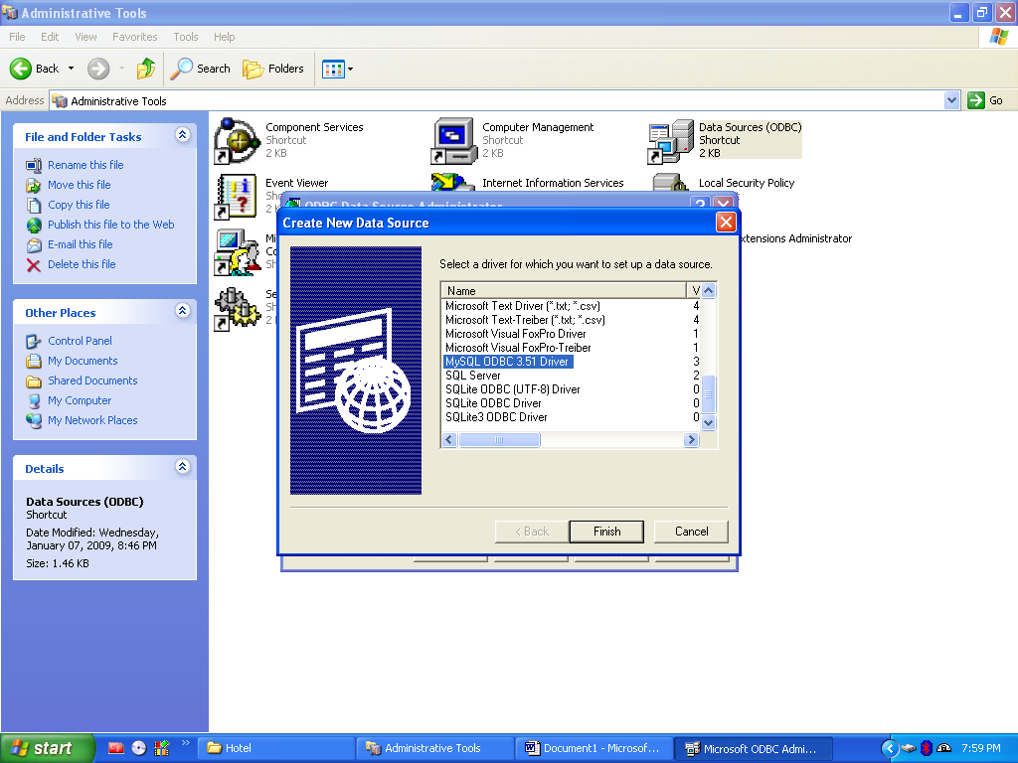

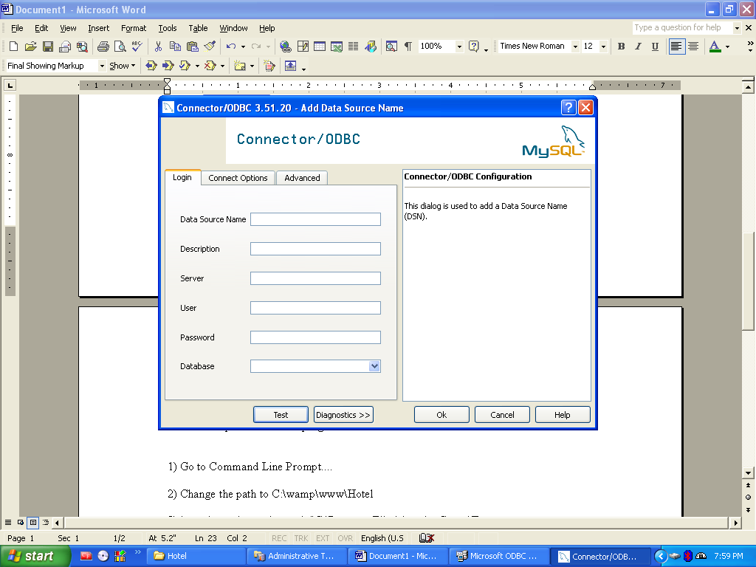
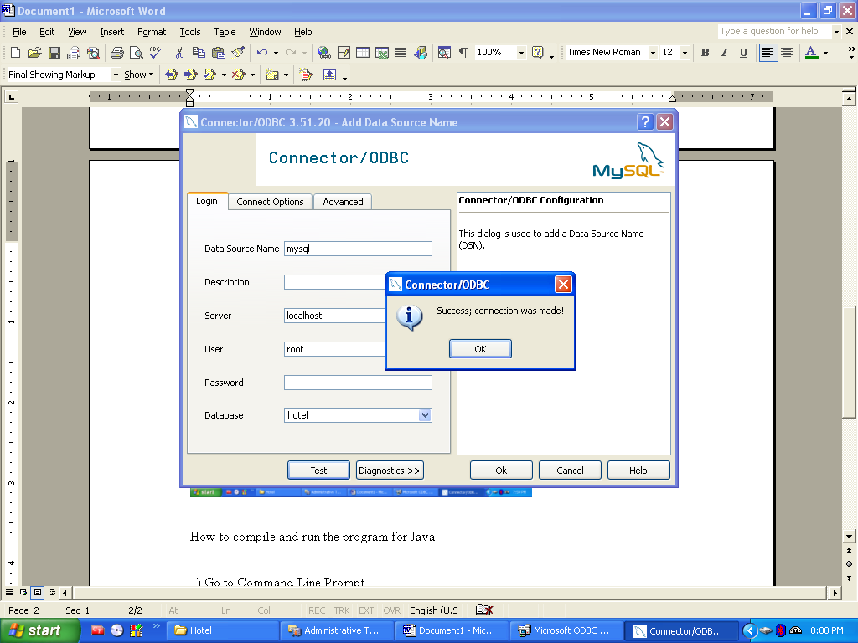

How to compile and run the program for Java

1) Go to Command Line Prompt....

2) Change the path to C:\wamp\www\Hotel

3) javac insert.java -classpath "C:\Program Files\Apache Group\Tomcat 4.1\common\lib\servlet.jar"

4) Copy the insert.class file from C:\wamp\www\Hotel to C:\Program Files\Apache Group\Tomcat

4.1\webapps\examples\WEB-INF\classes

5) Start the Tomcat Server.

6) Fill the details and check the results.

How to set Java Environmental Variables….

My Computer→Properties→Advanced tab→ Environmental Variables→Path(Edit)→;Path_To_Java;

